**FINAL CAPSTONE PROJECT SUBMISSION**

**Github Url:**

[**https://github.com/onlyforcloudaws/reactjs-demo.git**](https://github.com/onlyforcloudaws/reactjs-demo.git)

**Deployed site url:**

[**http://13.235.23.144/**](http://13.235.23.144/)

**Docker images:**

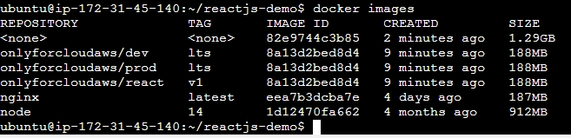

**Security groups**

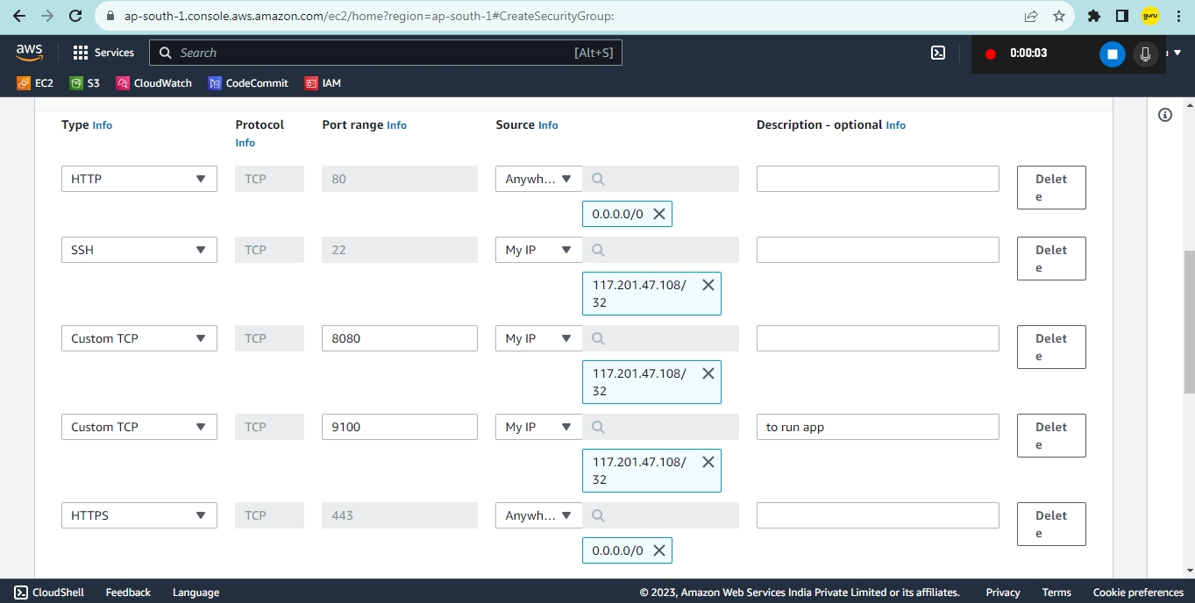

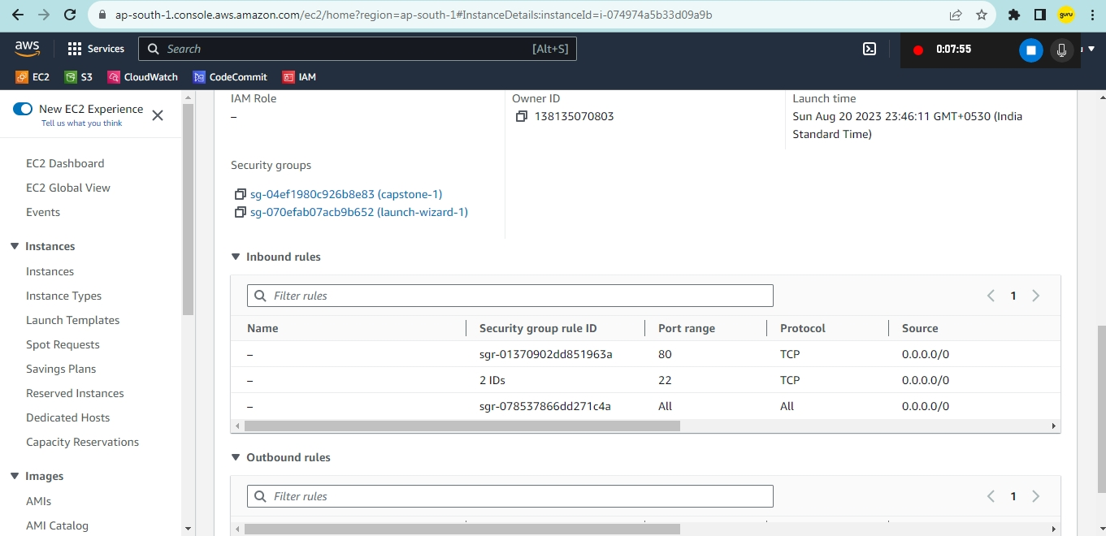

**Ec2-instance:**

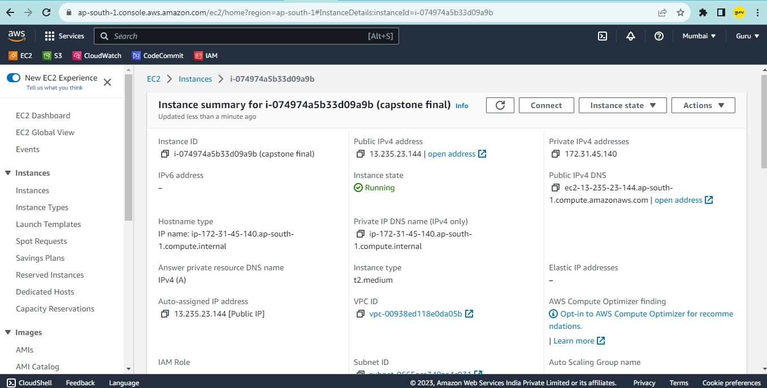

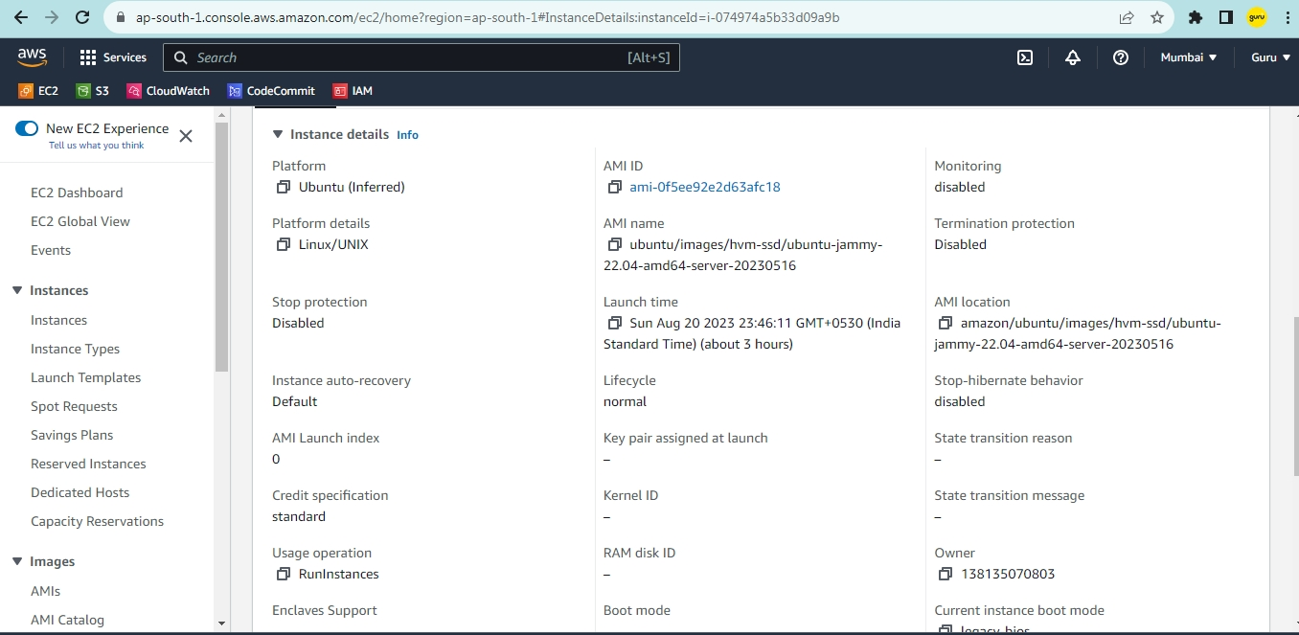

**onlyforcloudaws/dev**

**onlyforcloudaws/prod**

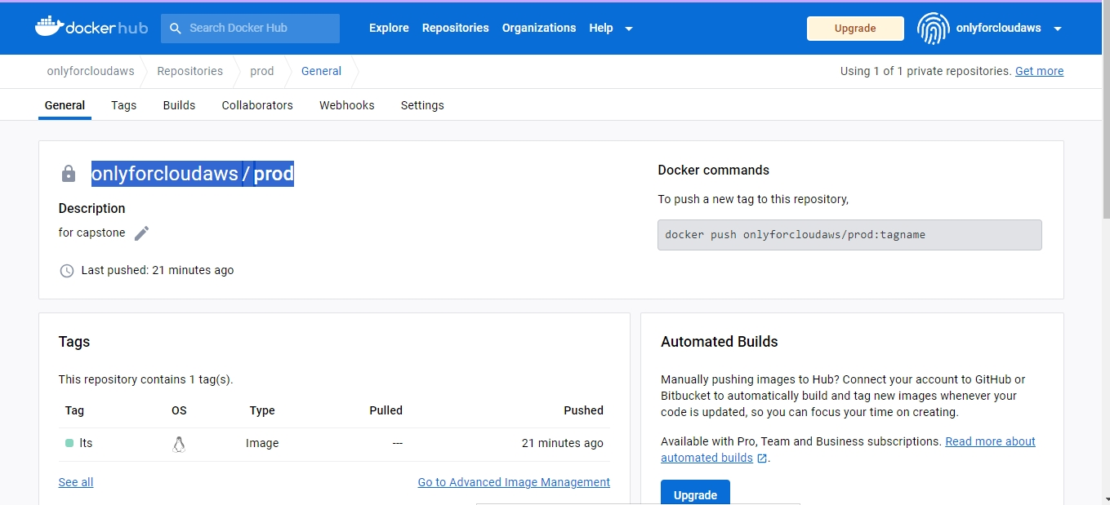

**Java installation:**

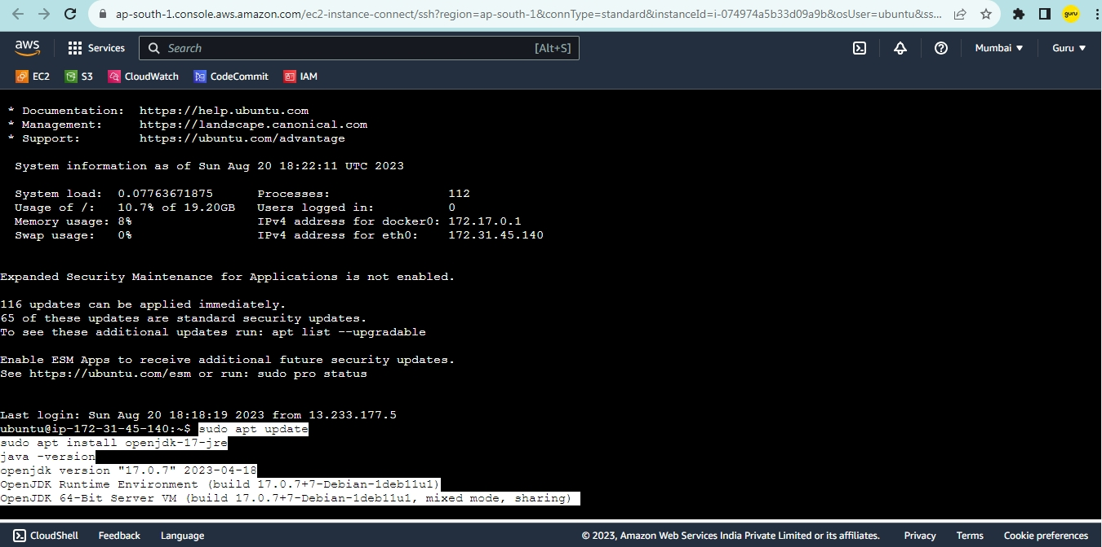

**Jenkins installation:**

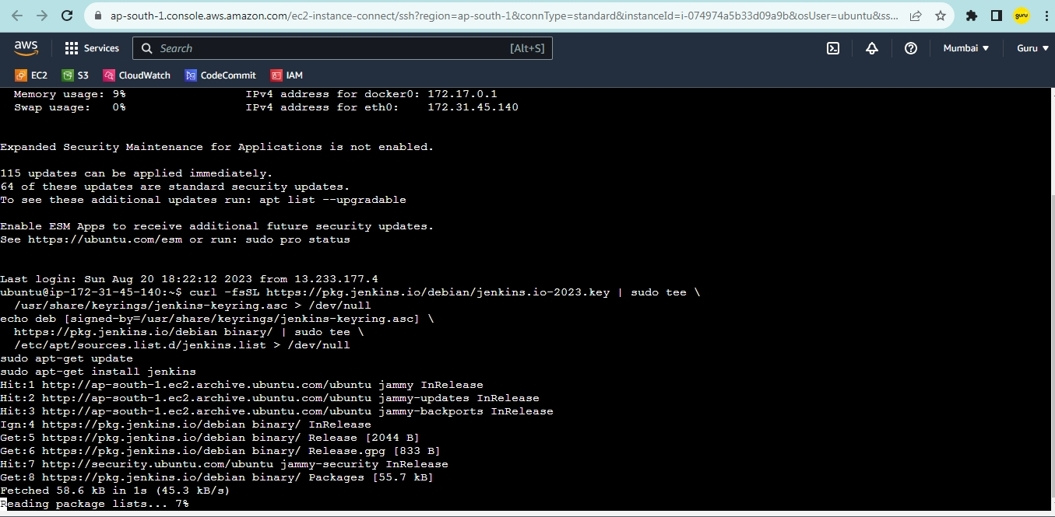

**Jenkins initial page:**

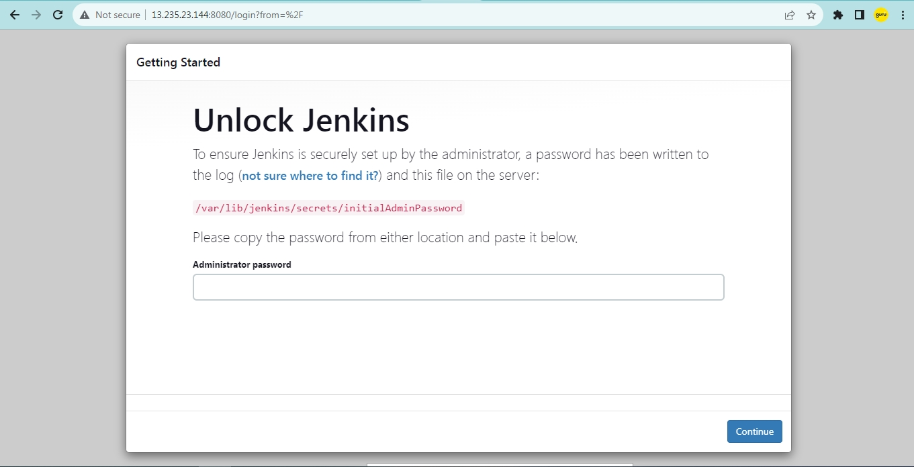

**Jenkins plugins installation:**

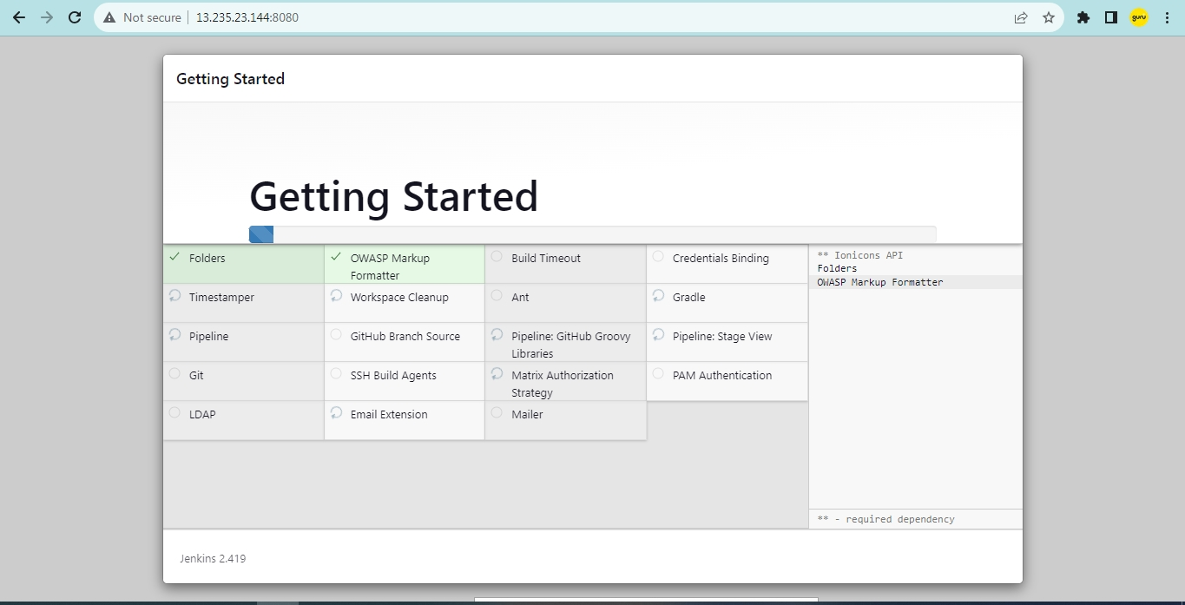

**Jenkins Configuration:**

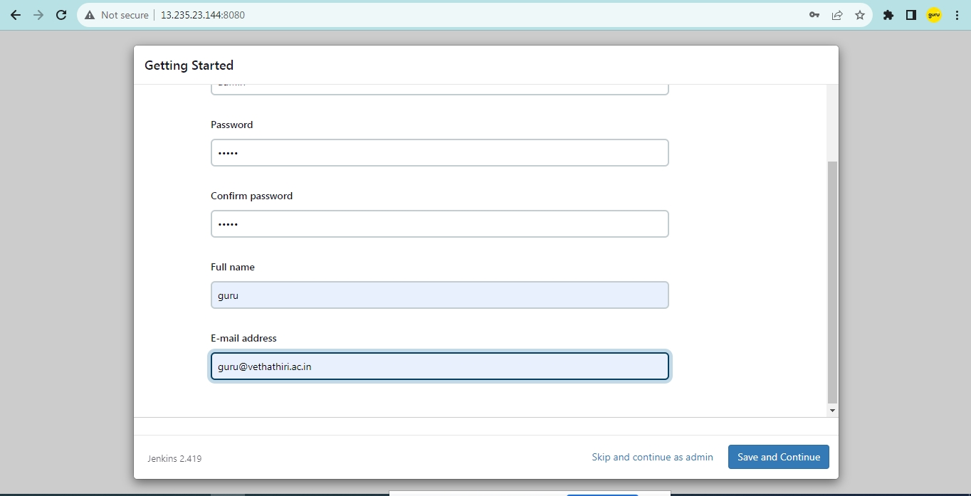

**Plugins Installed:**

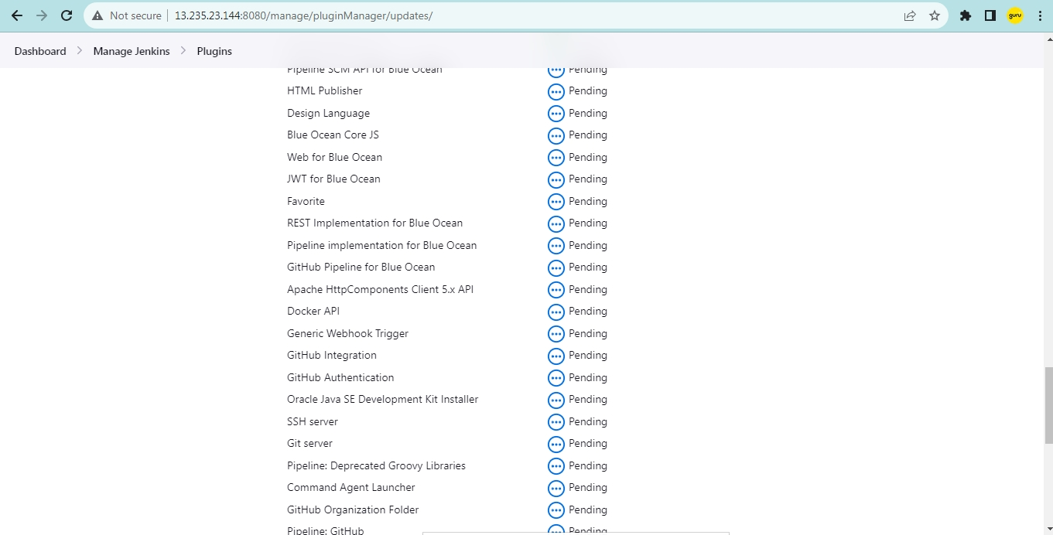

**Git commands:**

**Adding git credentials in Jenkins:**

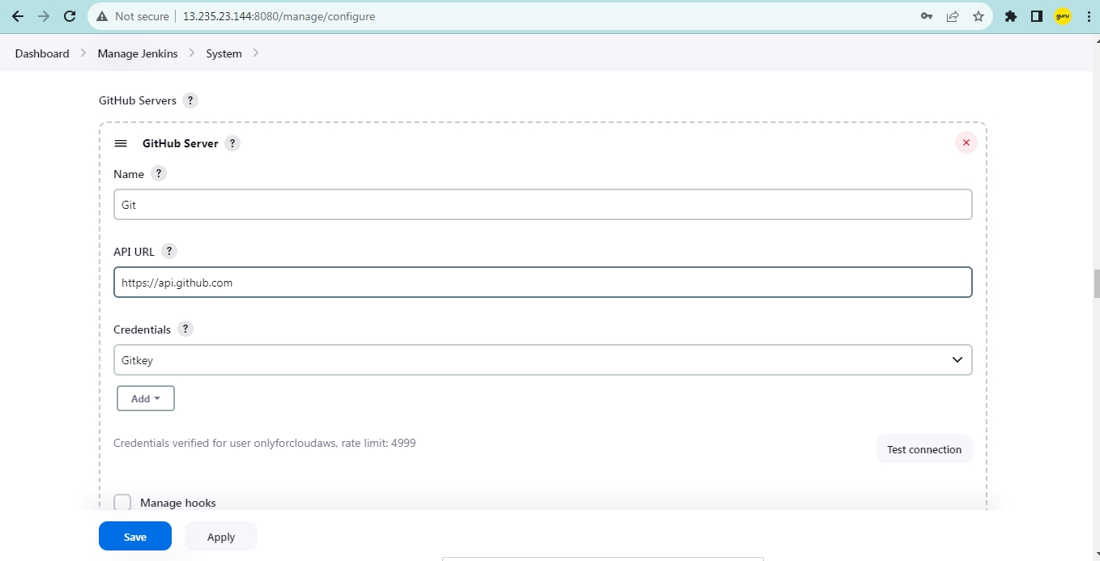

**Git Repo:**

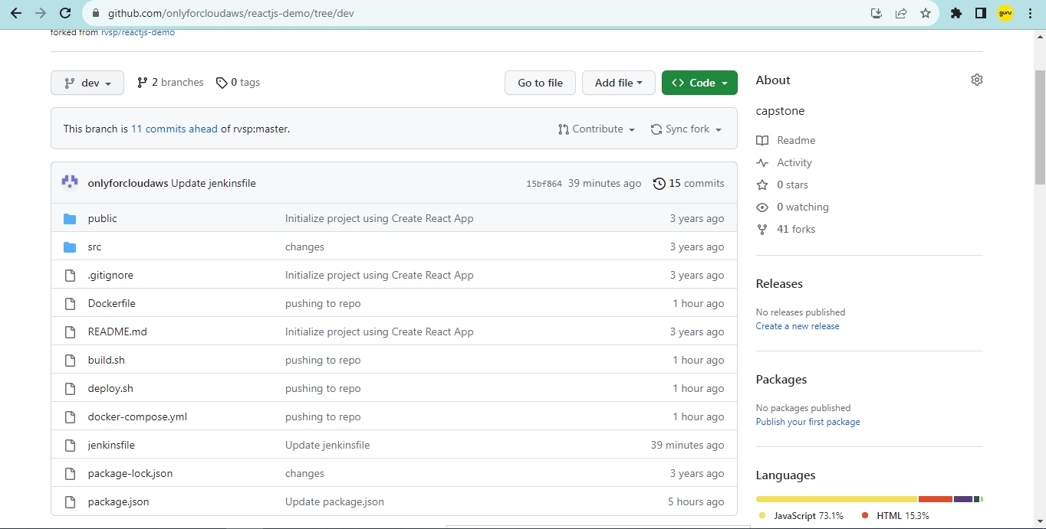

**Git add and commit:**

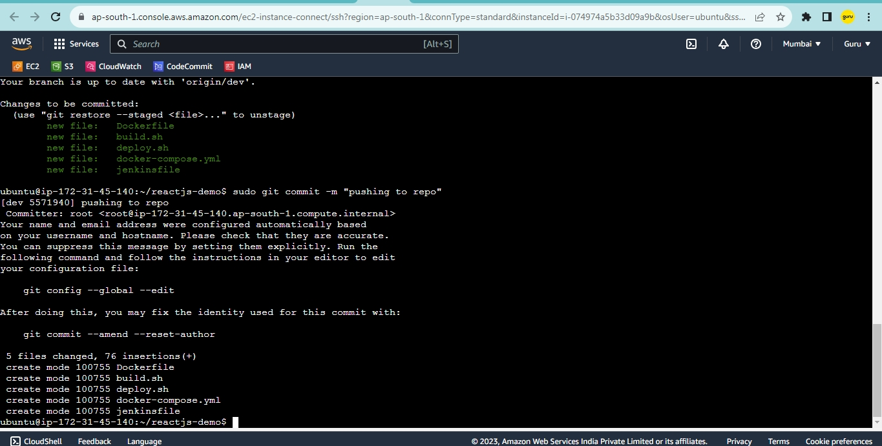

**Added git webhooks:**

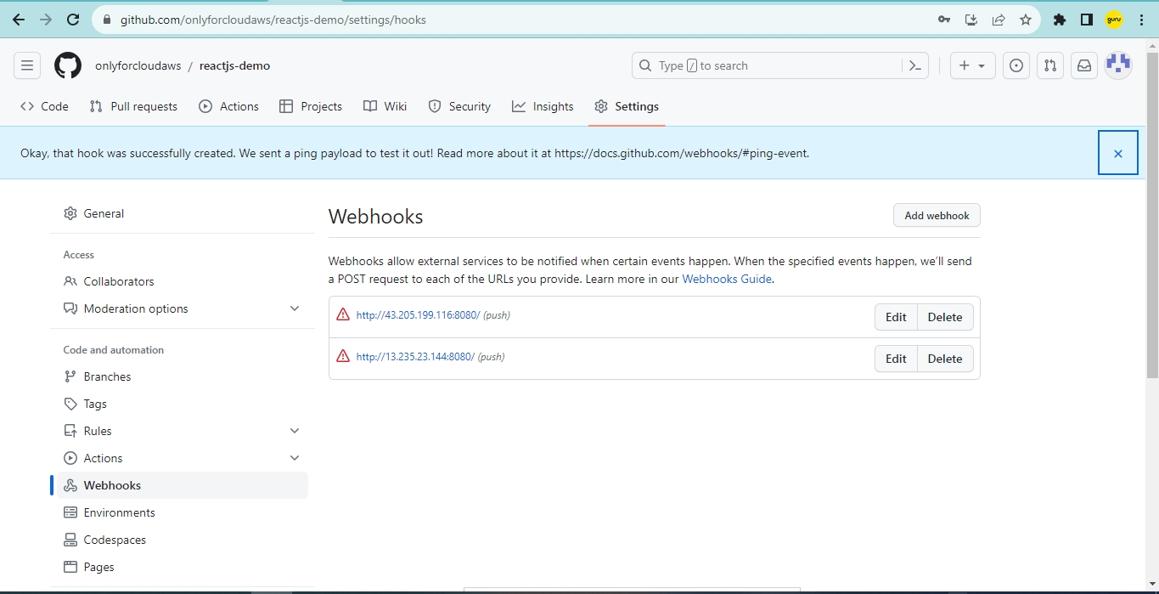

**Final build:**

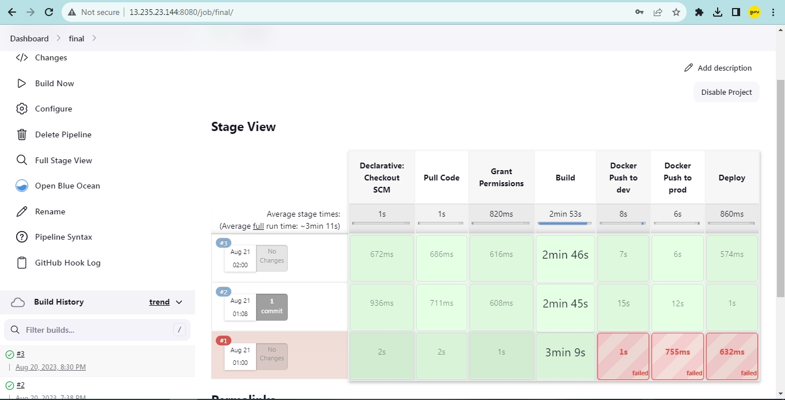

**Final Output:**

**Monitoring Final**

**Emails Notification:**

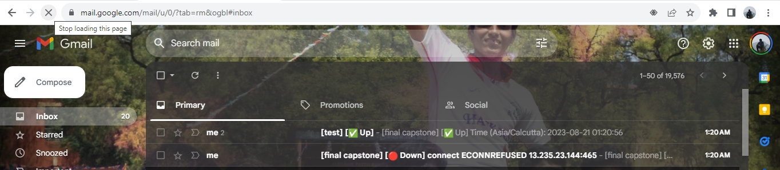

**Detail:**

**Up email:**

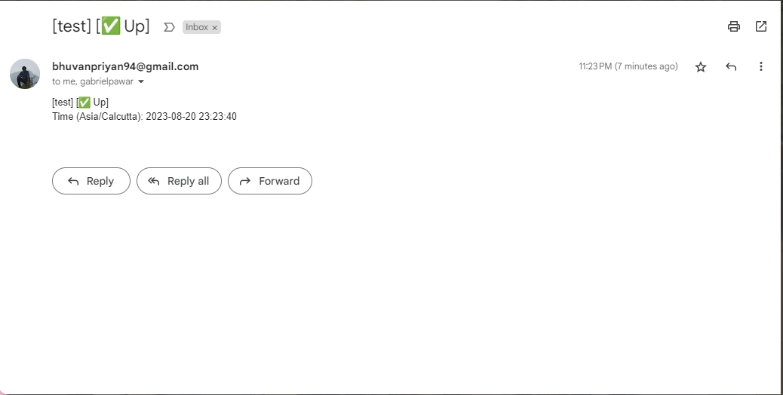

**Down email:**

